Intro

The Purpose of this lab activity is to observe osmosis by leaving potato slices in different solutions of sugar. After twenty-four hours we will return and record data about the state of the potatoes. The two components of the solution we will place the potatoes in are the solvents and solutes, where the solutes are dissolved by the solvents. Selective permeability is a cell membrane’s ability to allow only certain molecules through while other molecules cannot pass. The potato cell membrane will only allow certain amounts of the solvent through depending on the type of liquid it is in. A hypertonic solution has more solutes than surrounding liquids, while a hypotonic solution has less solutes than everything around it. A hypertonic solution outside a cell would cause it to shrink, while a hypotonic solution outside a cell would cause it to swell because of water entering and exiting the cell. An isotonic solution has an equal amount of solute compared to nearby solutions and cells will not shrink or expand. An isotonic solution is needed for cells in order for them to not burst or dehydrate. The lab will go over this and allow us to observe how potato cells react in hypotonic, hypertonic, and isotonic solutions.

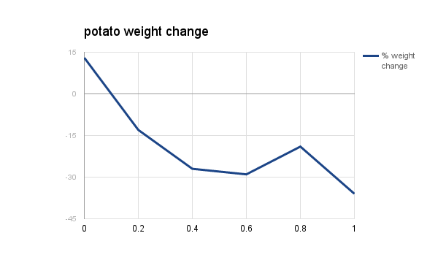

Hypothesis

The concentration of the external environment will determine if a cell gains or loses mass

Did the data support the Hypothesis?

Yes. The potato weight changed in proportion with the solution concentration.

What happened in each environment?

The potatoes absorbed and released water depending on the solution.

Why did this happen?

It happened by hypo and hypertonic solutions that had different amounts of sugar.

What is the concentration where the red star is?

It is isotonic. The potato is not gaining or losing water.

What is the dependant variable?

The potato weight change is the dependant variable.

What is homeostasis?

Homeostasis is the ability of a living thing to regulate conditions like temperature, or in this lab, an isotonic state inside a cell.